For preclinical conservative dentistry and endodontics exercises you should have:
- Disposable medical gloves (in adequate size), doctor’s gown, face mask (surgical), goggles or protect visor
- Working model for Frasaco phantom® with elastic gum (standard working model AG3) or with rigid gum (standard working model A3) (http://www.frasaco.de)1 kit for 2 students
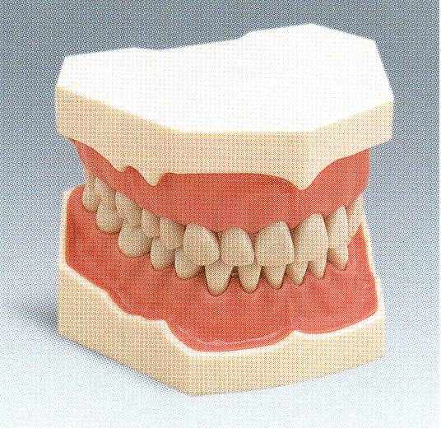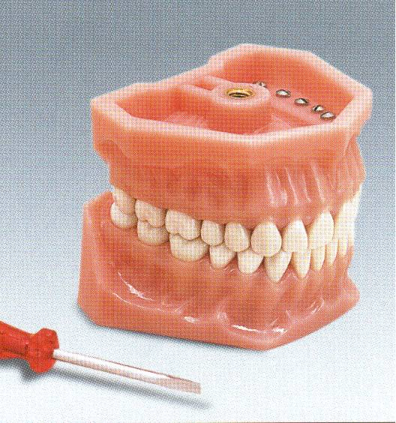

AG3 A3
(fot. Frasaco)

- Rotary cutting instruments set (see below)
- Syringe 5ml 3 pieces, needle 0,5 for root canal irrigation
- Wood wedges and polishing & finishing discs (1 set for training group of students)
endodontics
- 5 natural teeth (stored in thymol water solution or Aldesane)
- endodontic training blocks 4 pieces (curved canal, not s-type) (e.g. Morita, VDW or Frasaco)

- hand instrunents1 box (assortment 15-40) for 1 student (S-files are recommended e.g. Poldent)
- Paper points 1 box (assortment 15-40) for 5 students
- Gutta Percha points 1 box (assortment 15-40) for 5 students for 5 students
- Finger spreader 1 box (assortment 15-40) for 5 students
- Root canal reamers (drills) “Gates”, (assortment 01-06 e.g.: GAE010619 POLDENT catalogue) for 5 students
- Thermafil or SoftCore obturators (or similar) 3 pieces (ISO 25-30 taper 2 lub 4 size)
Rotary cutting instruments:
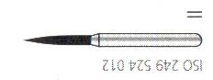
1. Diamond cutting instruments with friction-grip shank (recommended size of grain -fine 27-76µm, red colour code)
    - Flame (e.g. Swiss Tec ISO 249 524 012 e.g. POLDENT catalogue)
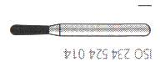
    - Pear 2 pieces (np. Swiss Tec ISO 234 524 010 i ISO 234 524 014 e.g. POLDENT catalogue)

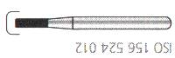
    - Rounded end cylinder (not round end!!) 2 pieces (e.g. Swiss Tec ISO 156 524 012 i ISO 156 524 014 e.g. POLDENT catalogue)
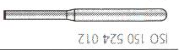
    - End cutting cylinder (np. Swiss Tec ISO 150 524 012 e.g. POLDENT catalogue)

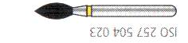
- Football, size of grain fine 27-76µm, yellow colour code (np. Swiss Tec ISO 257 504 023 e.g. POLDENT catalogue)
2. Burs, latch-type angle handpiece shank (wider shank)
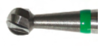
- round (rose) 4 pieces size 010,012,014,018 (e.g. medin ISO 001 001 010, ISO 001 001 014 i ISO 001 001 018 e.g. Medin catalogue– 142 51 1033, 1053, 1073)

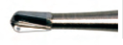
- Pear bur (np. Meisinger ISO 237 001 012, wg katalogu f-my Meisinger lub ISO 138 006 010 czyli 142 51 1293 wg katalogu Medin - )

The NiTi S5 or NiTi TEE ND Poldent rotary file (1 intro set) are higly recomended (or similar instruments set)

Wood wedges, green (e.g. KERR®), discs e.g.: OptiDisc® KERR or Sof-Lex® 3M ESPE.
Round bur have several ISO codes, carbide burs are beter then steel

